# CS 340 README

## About the Project/Project Title

We are working for Global Rain and specialize in custom software design and development. We will be working with our client Grazioso Salvare, an innovative international rescue-animal training company. Together we are importing files from existing data through Mongo DB, from local animal shelters that allow for finding dogs to be trained as rescue dogs. This application will include a database and a client-facing web application dashboard that Grazioso Salvare users will have access to.

## Motivation

Grazioso Salvare identifies dogs that are good candidates for search-and-rescue training and certification. To help identify these candidates, our client has an agreement with a nonprofit agency who operate five animal shelters around Austin, Texas and will provide our client with the data necessary.

## Getting Started

To start this project, you would need start Follow these simple steps.

1: Enter the Mongo Data Base and then import the animal_shelter_outcome CSV file.

2: Once this is imported, then you would parse the data by creating both simple indexes and complex indexes.

3: Next, we would need to authenticate a user to access the database, and to do we have to create an admin and a user account.

4: Access python through jupyter notebook.

5: Import the Mongo database and other libraries necessary.

6: Update User and Password accordingly and initialize

7: Create a new Dash application to build and set the HTML/CSS requirements for layout and other components.

8: Create the app callback so the data frame can populate with the information.

9: Create callback to update the map according to the selected filter.

10: Create pie chart to show data and create the callback for pie chart updates.

## Installation

The tools required to access this program include a current version of Python, Jupyter Notebook, and access to the Mongo Database. The database you will need to have access to is the AAC database with the animals collection.

Python:

Latest for Mac is <https://www.python.org/ftp/python/3.12.4/python-3.12.4-macos11.pkg>

Latest for others are here: <https://www.python.org/downloads/>

Jupyter:

Instructions for Jupyter install are here: <https://jupyter.org/install>

MongoDB:

Instructions for MongoDB install are here: <https://www.mongodb.com/docs/manual/installation/>

Challenges that I encountered are importing and being able to use the necessary files such as Animal_Shelter, CRUD functions, and both together for the dashboard.

## Usage

### Importing AAC CSV File to MongoDB

CRUD: Creating Animal

CRUD: Update Functionality in Main.ipnyb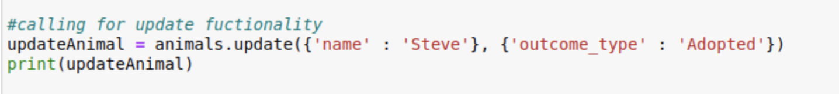

Dashboard Funtionality

## Contact

Cory Doak